Some Resources for Teaching Shakespeare

General Overviews:
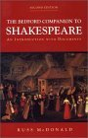
Russ McDonald. The Bedford Companion to Shakespeare: An Introduction with Documents, 2nd ed. Bedford/St Martin’s, 2001. Print. ISBN: 978-0312237134
J. C. Trewin. The Pocket Companion to Shakespeare’s Plays, rev. ed.. London: Mitchell Beazley, 1999. Print. ISBN: 1857323408
Leslie Dunton-Downer and Alan Riding. Essential Shakespeare Handbook. New York: D. K. Publishing, 2004.Print. ISBN: 0 7894 93333 0
Editions of the Plays
The Cambridge School Shakespeare Series:
Hamlet [The Cambridge School Shakespeare] 2nd ed. Richard Andrews (volume ed.), Rex Gibson (series ed.). Cambridge UP, 2005. Print. ISBN-13: 978-0521618748
Teaching Shakespeare:
Louis Fantasia. Instant Shakespeare: A Proven Technique for Actors, Directors, and Teachers. Chicago: Ivan R. Dee, 2002. Print. ISBN-13: 978-1566635035
Peggy O’Brien, ed. Shakespeare Set Free. Washington Square Press (2006):
Book 1: Teaching Romeo and Juliet: Macbeth: A Midsummer Night's Dream ,1993. Print. ISBN-13: 978-0743288507; Book 2: Teaching Hamlet, Henry IV, Part 1, 1994. Print. ISBN-13: 978-0743288491; Book 3: Teaching Twelfth Night, Othello, 1995. Print. ISBN-13: 978-0743288514.
For Younger (chronologically or at heart) Readers

Barbara Holdridge. Under the Greenwood Tree: Shakespeare for Young People. Owings Mills: Stemmer House, 1986. Print. ISBN: 978-0880450294
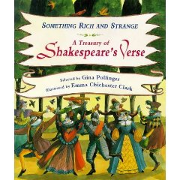
Pauline Nelson and Todd Daubert. Starting with Shakespeare: Successfully Introducting Shakespeare to Children. Westport: Teacher Idea Press, 2000. Print. ISBN: 1-56308-753-7.
Gina Pollinger. Something Rich and Strange: A Treasury of Shakespeare’s Verse. New York: Kingfisher, 1995. Print. ISBN: 978-0753402955
Anita Ganeri. The Young Person’s Guide to Shakespeare [Book and CD set]. London: Pavilion, 1999. Print. ISBN: 978-0152021016
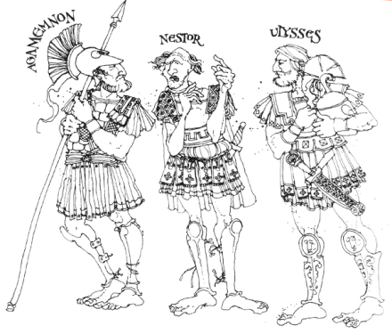
Renwick St James and James C. Christensen. A Shakespeare Sketchbook. Shelton: Greenwich Workshop Press, 2001. Print.

